NOTICE OF CANCELLATION OF MEETING
Notice is hereby given pursuant to the Open Meeting Act, Act 267, Public Acts of 1967, effective March 31, 1977, Highpoint Virtual Academy with office located at 210 E. Mesick Ave. Mesick, MI 49668, filed this Notice of Cancellation.
Original Meeting Date, Time and Place:
November 15, 2018 @ 3:00 Highpoint Virtual Academy with office located at 210 E. Mesick Ave. Mesick, MI 49668
This is a:

☐ Special Meeting ☐ Emergency Meeting

☒ Canceled Meeting ☐ Continued or Reconvened

☐ Rescheduled Regular Meeting
New Meeting Date, Time and Place:
Will not be rescheduled. The Board will meet at its regularly scheduled day and time in December.
Remarks:
Highpoint Virtual Academy of Michigan Board Meeting canceled due to lack of agenda items.

NAME OF PERSON REPORTING:

Name (Type or Print) : Mary Moorman

Title: Head of School

Signature: 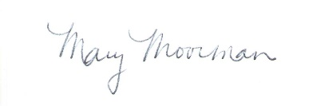

Date: November 5, 2018

